R Notebook

# Graph

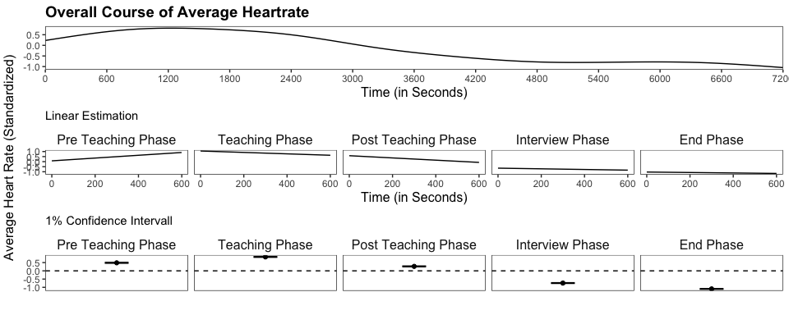

# Slopes and Intercepts

| Phase | n | Mean(Intercept) | SD(Intercept) | p-Value (Intercept) | Mean(Slope) | SD(Slope) | p-Value (Slope) |
| --- | --- | --- | --- | --- | --- | --- | --- |
| Pre Teaching Phase | 6485 | 0.0632356 | 0.8387559 | 0.5130297 | 0.0837692 | 0.1328339 | 0.0000005 |
| Teaching Phase | 6716 | 1.0336329 | 0.6681817 | 0.0000000 | -0.0412045 | 0.1033556 | 0.0008512 |
| Post Teaching Phase | 6265 | 0.5686287 | 0.5473590 | 0.0000000 | -0.0638411 | 0.1021773 | 0.0000006 |
| Interview Phase | 5926 | -0.6513749 | 0.4662307 | 0.0000000 | -0.0206627 | 0.0684818 | 0.0103452 |
| End Phase | 5563 | -1.0338585 | 0.4762552 | 0.0000000 | -0.0120019 | 0.0709541 | 0.1445017 |

# Plots for all phases

## $`Preparation Phase`

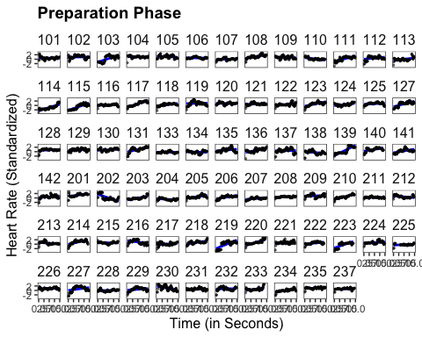

##   
## $`Teaching Phase`

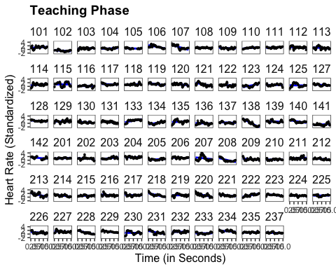

##   
## $`Post Teaching Phase`

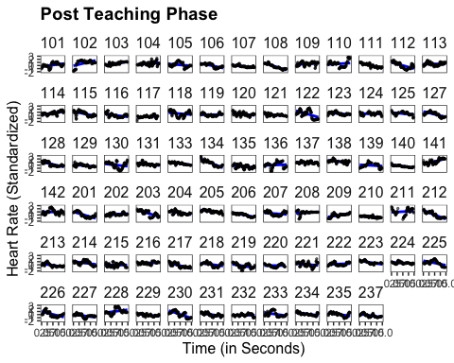

##   
## $`Interview Phase`

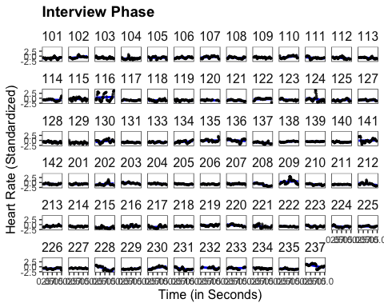

##   
## $`End Phase`

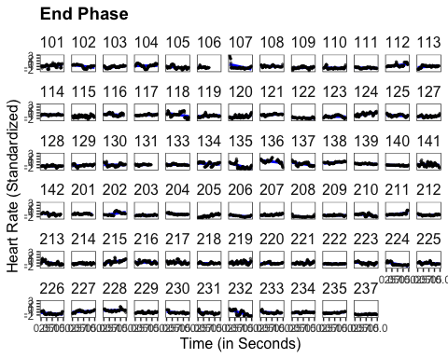

# t-Tests

using heart rate means

## Teaching vs. Interview

##   
## Paired t-test  
##   
## data: .$mean_heart_rate[.$time_span == "teaching"] and .$mean_heart_rate[.$time_span == "interview"]  
## t = 21.78, df = 75, p-value < 2.2e-16  
## alternative hypothesis: true mean difference is not equal to 0  
## 95 percent confidence interval:  
## 1.443945 1.734678  
## sample estimates:  
## mean difference   
## 1.589311

## [1] 4.020572  
## attr(,"magnitude")  
## [1] "large"

## teaching vs. end

##   
## Paired t-test  
##   
## data: .$mean_heart_rate[.$time_span == "teaching"] and .$mean_heart_rate[.$time_span == "end"]  
## t = 28.235, df = 75, p-value < 2.2e-16  
## alternative hypothesis: true mean difference is not equal to 0  
## 95 percent confidence interval:  
## 1.791787 2.063820  
## sample estimates:  
## mean difference   
## 1.927803

## [1] 4.844642  
## attr(,"magnitude")  
## [1] "large"

## interview vs. end

##   
## Paired t-test  
##   
## data: .$mean_heart_rate[.$time_span == "interview"] and .$mean_heart_rate[.$time_span == "end"]  
## t = 5.4847, df = 75, p-value = 5.357e-07  
## alternative hypothesis: true mean difference is not equal to 0  
## 95 percent confidence interval:  
## 0.2155489 0.4614348  
## sample estimates:  
## mean difference   
## 0.3384919

## [1] 0.9231646  
## attr(,"magnitude")  
## [1] "large"

# Multiple Linear Regression

# Pre Teaching Phase

##   
## % Table created by stargazer v.5.2.3 by Marek Hlavac, Social Policy Institute. E-mail: marek.hlavac at gmail.com  
## % Date and time: Thu, Apr 27, 2023 - 15:27:25  
## \begin{table}[!htbp] \centering   
## \caption{}   
## \label{}   
## \begin{tabular}{@{\extracolsep{5pt}}lccccc}   
## \\[-1.8ex]\hline   
## \hline \\[-1.8ex]   
## & \multicolumn{5}{c}{\textit{Dependent variable:}} \\   
## \cline{2-6}   
## \\[-1.8ex] & \multicolumn{5}{c}{Slope} \\   
## \\[-1.8ex] & (1) & (2) & (3) & (4) & (5)\\   
## \hline \\[-1.8ex]   
## Disruption Factor & 0.018 & & & 0.013 & 0.010 \\   
## & (0.014) & & & (0.014) & (0.014) \\   
## & & & & & \\   
## Confidence Factor & & $-$0.020 & & $-$0.017 & $-$0.008 \\   
## & & (0.013) & & (0.014) & (0.015) \\   
## & & & & & \\   
## Teaching Experience & & & $-$0.004$^{**}$ & & $-$0.003 \\   
## & & & (0.002) & & (0.002) \\   
## & & & & & \\   
## Constant & $-$0.010 & 0.243$^{**}$ & 0.104$^{***}$ & 0.145 & 0.114 \\   
## & (0.074) & (0.103) & (0.018) & (0.147) & (0.147) \\   
## & & & & & \\   
## \hline \\[-1.8ex]   
## Observations & 70 & 70 & 70 & 70 & 70 \\   
## R$^{2}$ & 0.025 & 0.034 & 0.066 & 0.046 & 0.079 \\   
## Adjusted R$^{2}$ & 0.011 & 0.020 & 0.052 & 0.018 & 0.037 \\   
## \hline   
## \hline \\[-1.8ex]   
## \textit{Note:} & \multicolumn{5}{r}{$^{*}$p$<$0.1; $^{**}$p$<$0.05; $^{***}$p$<$0.01} \\   
## \end{tabular}   
## \end{table}   
##   
## % Table created by stargazer v.5.2.3 by Marek Hlavac, Social Policy Institute. E-mail: marek.hlavac at gmail.com  
## % Date and time: Thu, Apr 27, 2023 - 15:27:25  
## \begin{table}[!htbp] \centering   
## \caption{}   
## \label{}   
## \begin{tabular}{@{\extracolsep{5pt}} c}   
## \\[-1.8ex]\hline   
## \hline \\[-1.8ex]   
## Pre Teaching Phase \\   
## \hline \\[-1.8ex]   
## \end{tabular}   
## \end{table}

# Post Teaching Phase

##   
## <table style="text-align:center"><tr><td colspan="6" style="border-bottom: 1px solid black"></td></tr><tr><td style="text-align:left"></td><td colspan="5"><em>Dependent variable:</em></td></tr>  
## <tr><td></td><td colspan="5" style="border-bottom: 1px solid black"></td></tr>  
## <tr><td style="text-align:left"></td><td colspan="5">Slope</td></tr>  
## <tr><td style="text-align:left"></td><td>(1)</td><td>(2)</td><td>(3)</td><td>(4)</td><td>(5)</td></tr>  
## <tr><td colspan="6" style="border-bottom: 1px solid black"></td></tr><tr><td style="text-align:left">Disruption Factor</td><td>-0.011</td><td></td><td></td><td>-0.013</td><td>-0.015</td></tr>  
## <tr><td style="text-align:left"></td><td>(0.011)</td><td></td><td></td><td>(0.011)</td><td>(0.011)</td></tr>  
## <tr><td style="text-align:left"></td><td></td><td></td><td></td><td></td><td></td></tr>  
## <tr><td style="text-align:left">Confidence Factor</td><td></td><td>-0.004</td><td></td><td>-0.008</td><td>-0.005</td></tr>  
## <tr><td style="text-align:left"></td><td></td><td>(0.010)</td><td></td><td>(0.011)</td><td>(0.012)</td></tr>  
## <tr><td style="text-align:left"></td><td></td><td></td><td></td><td></td><td></td></tr>  
## <tr><td style="text-align:left">Teaching Experience</td><td></td><td></td><td>-0.001</td><td></td><td>-0.001</td></tr>  
## <tr><td style="text-align:left"></td><td></td><td></td><td>(0.001)</td><td></td><td>(0.002)</td></tr>  
## <tr><td style="text-align:left"></td><td></td><td></td><td></td><td></td><td></td></tr>  
## <tr><td style="text-align:left">Constant</td><td>-0.003</td><td>-0.031</td><td>-0.058<sup>***</sup></td><td>0.069</td><td>0.058</td></tr>  
## <tr><td style="text-align:left"></td><td>(0.057)</td><td>(0.081)</td><td>(0.014)</td><td>(0.115)</td><td>(0.116)</td></tr>  
## <tr><td style="text-align:left"></td><td></td><td></td><td></td><td></td><td></td></tr>  
## <tr><td colspan="6" style="border-bottom: 1px solid black"></td></tr><tr><td style="text-align:left">Observations</td><td>70</td><td>70</td><td>70</td><td>70</td><td>70</td></tr>  
## <tr><td style="text-align:left">R<sup>2</sup></td><td>0.016</td><td>0.002</td><td>0.005</td><td>0.024</td><td>0.030</td></tr>  
## <tr><td style="text-align:left">Adjusted R<sup>2</sup></td><td>0.002</td><td>-0.012</td><td>-0.010</td><td>-0.005</td><td>-0.014</td></tr>  
## <tr><td colspan="6" style="border-bottom: 1px solid black"></td></tr><tr><td style="text-align:left"><em>Note:</em></td><td colspan="5" style="text-align:right"><sup>*</sup>p<0.1; <sup>**</sup>p<0.05; <sup>***</sup>p<0.01</td></tr>  
## </table>